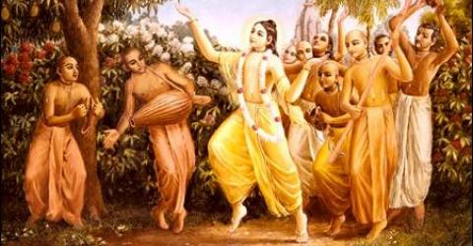

December 2010 Special Edition
www.soldiersofgodhead.yolasite.com
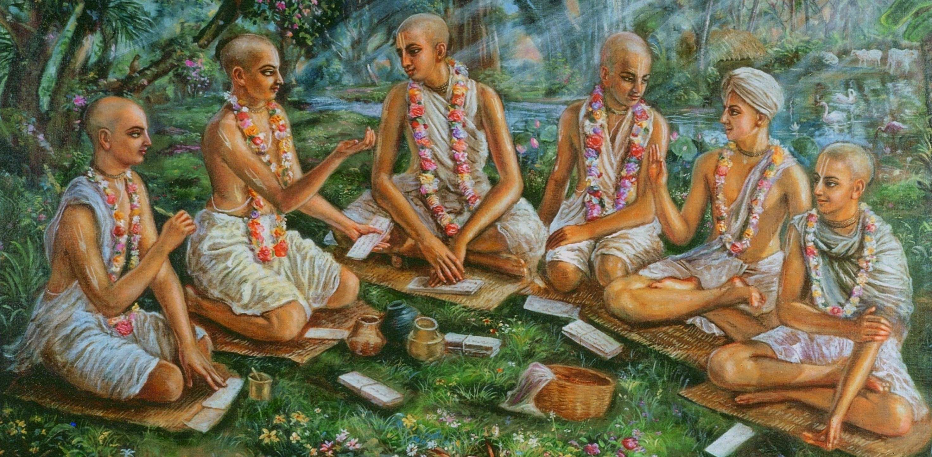

This month’s edition of the Soldiers of Godhead is a special edition dedicated to the Six Goswamis of Vrindavan.
Contents
Sr.no Topic Page no.
- Srila Sanatana Goswami 5

- Srila Rupa Goswami 15

- Srila Raghunath Bhatta Goswami 20

- Srila Raghunath Dasa Goswami 23

- Srila Gopal Bhatta Goswami 27

- Srila Jiva Goswami 34

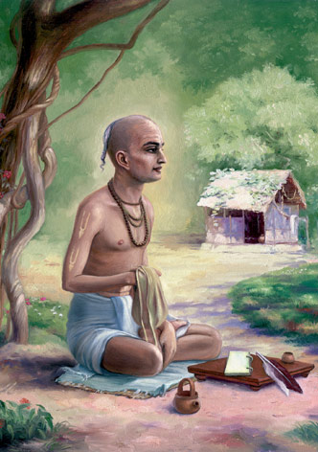
Srila Sanatana Goswami

Srila Sanatana Goswami
Srila Sanatana Goswami (1488-1558 CE) was the principal disciple of Lord Chaitanya Mahaprabhu and the senior most of the Six Goswamis of Vrindavan. He was born in a Sarasvata Brahmana family in Jessore, east Bengal (present day Bangladesh) and was the elder brother of Srila Rupa Goswami and Anupama. Srila Sanatana Goswami has made a very significant contribution to the Bhakti tradition of the Gaudiya Vaishnava School in the form of his literary contributions.
Sanatana and his two brothers, Rupa and Anupama, were always absorbed in bhava bhakti from early childhood. Remembering Vrndavana, they named the forests in which they played after Vraja's twelve forests (Talavana, Madhuvana, Kamyavana, Mahavana). They called their favorite bathing ponds Radha-kunda and Syama-kunda.
In his youth, Sri Sanatana dreamt that a beautiful brahmana boy gave him a Srimad Bhagavatam. Feeling ecstatic he awoke. But seeing neither the boy nor the Bhagavatam he felt sad. When Sanatana began his puja that morning, however, Krishna Himself, disguised as a beautiful brahmana boy, came and said, "Take this Srimad Bhagavatam from Me, always study it, and you will attain perfection."
In Krishna-lila-stava, Sri Sanatana Gosvami glorifies the Srimad Bhagavatam: "0 holy Bhagavata, you are my only company, my only friend, and my guru. You are my greatest treasure and my personal savior. You are the emblem of my highest fortune and the very form of ecstasy. I offer my obeisances unto you."
Sanatana and his brothers studied Nyaya (rhetortic) and Vedanta from the famous logician Vasudeva Sarvabhauma Bhattacharya. They also studied under Sarvabhauma's brother, Madhusudana Vidyavacaspati, from whom Sanatana took initiation in his childhood. On the death of his father, Sanatana Goswami was forced to take up the post of Sakara Mallik (treasurer) to the new ruler of Bengal, Alauddin Hussein Shah (ruled 1493-1519 CE), while his brother Rupa was given the post of Dabir-i-khas (private secretary).
Sanatana and Rupa received land from the government for their personal use in Fatehbad, where they built a huge palace. They also built several beautiful mansions at Ramakeli. It was at Ramakeli in 1510 that Sanatana and his two brothers met Chaitanya Mahaprabhu for the first time. After meeting them, Chaitanya gave them the names Rupa, Sanatana and Anupama. Due to this meeting, the brothers decided to renounce the world and join Chaitanya and his entourage. Rupa resigned from his post, but Sanatana’s resignation was refused by the Sultan. Sanatana stopped coming to court and feigned sickness. But when the Sultan sent his personal physicians to treat Sanatana they returned and reported that Sanatana was in perfectly good health. The Sultan personally visited Sanatana and tried to convince him to continue to render his governmental duties and accompany him on a military campaign against the neighboring state of Orissa. Upon Sanatana’s refusal, Hussein Shah had him thrown into prison.
While in prison, Sanatana received a letter from his brother Rupa telling him that Chaitanya Mahaprabhu had left Puri to go to Vrindavana and that Rupa and Anupama had decided to meet him there. Sanatana managed to bribe the jailer with money Rupa had sent him for emergencies. Sanatana then crossed the Ganges River and made his way towards Vrindavana. As Sanatana made his way to Vrindavana he learned that Chaitanya Mahaprabhu had already left Vrindavana and was then residing in Benares.
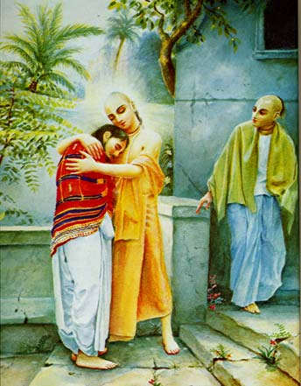

Chaitanya Mahaprabhu receiving Srila Sanatana Goswami in Benares.
In Benares, Sanatana met Chaitanya, who imparted to him instructions pertaining to sambandha-jnana (knowledge of the self and one's relationship with God). Chaitanya taught that the constitutional identity of each soul is to be an eternal servant of God. Chaitanya explained his teachings to Sanatana by summarizing them in three categories: sambandha (one's relationship with Godhead), abhidheya (the method for reviving that relationship), and prayojana (the ultimate attainment of the supreme goal of life). After instructing Sanatana in the sambandha aspect of Gaudiya Vaishnava theology, Chaitanya instructed him to go to Vrindavana, where Sanatana visited the sites connected to Krishna’s pastimes. When Sanatana later went to Puri and met Chaitanya once more, Chaitanya gave him four direct instructions:
1) To write books teaching Bhakti yoga, the process of devotion to Krishna
2) To discover and excavate the places in Vrindavana where Krishna had his pastimes
3) To establish the service of the deity (murthis) of Krishna in Vrindavana
4) To compile a book establishing the proper behavior for devotees of Krishna in order to create the foundations of a Vaishnava society.
Sanatana Goswami returned to Vrindavana, where he located various lost holy places. He also established the worship of the deity of Madana-mohana. Soon after Sanatana discovered the deity, a rich officer in the Moghul army named Krishna Dasa Kapura built a temple for Madana-mohan. This later became one of the seven principal temples of Vrindavana. The Radha-Madana Mohana mandir established by Sanatana Gosvami was the first one opened in Vrndavana by the six Goswamis. Described as "the personal extension of the body of Sri Caitanya Mahaprabhu," Sri Sanatana is the ideal spiritual master because he gives one shelter at the lotus feet of Madana Mohana. The three Vrndavana Deities (Madana Mohana, Govindaji and Gopinatha) are the life and soul of the Gaudiya Vaisnavas. The Deity of Madana Mohana has the specific quality of helping the neophyte devotees understand their eternal relationship with the Supreme Personality of Godhead, Lord Sri Krishna.
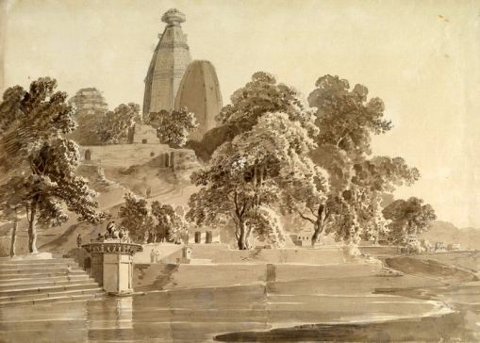
Madan Mohan Temple at Vrindavan, India.
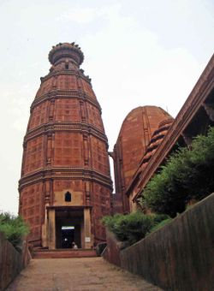

"Madana Mohana" means Krishna who is so indescribably beautiful that He even attracts Cupid, Kamadeva. Sanatana Gosvami is the sambandha acarya who gives us knowledge of our proper relationship with Krishna, And His Deity, Madana Mohana, helps us overcome our attraction for material sense gratification (Cupid) and fix our minds on devotional service. Sanatana Goswami died in the year 1558 CE. His samādhi (tomb) is located next to the Madana-Mohana temple.
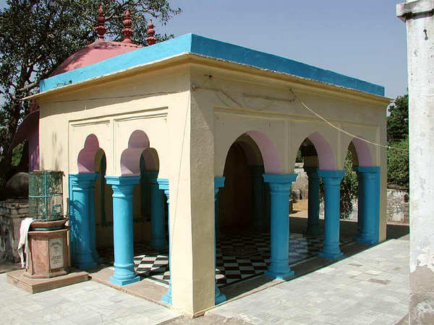

Srila Sanatana Goswami’s Samadhi behind Madan Mohan Temple in Vrindavan, India.

Sanatana Goswami wrote four important books in Sanskrit on Gaudiya Vaishnava philosophy:
Brihat-bhagavtamrita ("The Great Nectar of the Lord’s Devotees")
This work of 2,500 verses is divided into two parts. The first section explains the ontological hierarchy of the devotees of Krishna. The second section deals with the soul's journey to the eternal realm of Krishna. Narrated as stories, both sections explain many aspects of Gaudiya Vaishnava philosophy. Sanatana also wrote for this book his own commentary, called the Dig-darshini.
Hari-bhakti-vilasa ("Performance of Devotion to Hari")
This book was a joint work between Sanatana Goswami and Gopala Bhatta Goswami. Compiled on the order of Chaitanya Mahaprabhu, the book deals with the rituals and conduct of Gaudiya Vaisnavas. Sanatana also wrote an auto-commentary on Hari-bhakti Vilasa.
Krishna-lila-stava ("Glorification of the Pastimes of Krishna")
Krishna-lila-stava consists of 432 verses tracing Krishna’s pastimes as told in the Bhagavata Purana, from the beginning of the 10th Canto up through the vanquishing of Kamsa. Krishna-lila-stava is also sometimes referred to as the Dasama-charita.
Brihad Vaishnava Toshani ("That which brings Great Joy to the Devotees of Krishna")
The Brihad Vaishnava Toshani is Sanatana’s extensive commentary on the Tenth Canto of the Bhagavata Purana. This commentary is also known as the Dasama-tipanni.
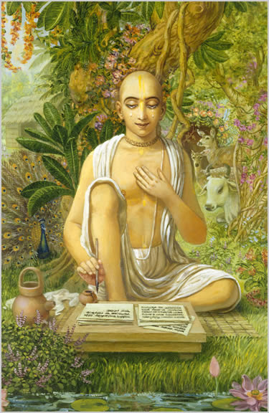
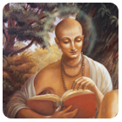
Srila Rupa Goswami

2. Srila Rupa Goswami
Srila Rupa Goswami (1489-1564) was the younger brother of Srila Sanatana Goswami and was one of the principal disciples of Lord Chaitanya Mahaprabhu and was one of the Six Goswamis of Vrindavan.
He had appeared in Vrindavan, India, five years after the appearance of Srila Sanatana Goswami. He along with Srila Sanatana Goswami and Anupama studies Nyaya shastra (Law) from the famous logician Vasudeva Sarvabahuma Bhattacharya and his brother Madhusudana Vidyavacaspati. They also studied Sanskrit, Arabic and Persian. Due to their noble characters and academic proficiency, Rupa and his elder brother Sanatana were later forced into government service by the sultan of Bengal, Alauddin Hussein Shah (1493-1519 CE) which led to their excommunication from Hindu society by the orthodox caste brahmanas of Gauda. Rupa became the Sultan's chief secretary (dabir khas), while Sanatana became the state revenue minister (sakara mallika).
Rupa and his brothers made their residence at the state capital of Ramakeli and it was here, in 1514 CE, that they met Chaitanya Mahaprabhu for the first time. The meeting changed their lives and they decided to leave the service of the Sultan and take up a life of renunciation in the association of Lord Chaitanya and his followers. Rupa loaded all his wealth onto two boats and left with his brother Anupama for their ancestral home at Fatiabad in Jessore, where they distributed it. They then sent two messengers to Puri in Orissa to get news of Chaitanya Mahaprabhu's plans. The messengers returned with the news that Chaitanya had already left Puri for Vrindavana. Rupa and Anupama immediately decided to go and they wrote a letter to Sanatana telling him of their plans and asking him to meet them in Vrindavana. They also told him that they had left 10,000 gold coins in case he was in need of financial help. Later, when Sanatana was thrown into prison by the Sultan for disobedience, he used this money to bribe the jailer and escaped to Varanasi to meet with Chaitanya Mahaprabhu.
After visiting Vrindavana, Chaitanya stopped at the holy city of Prayaga (modern day Allahabad in Uttar Pradesh). It was here that Rupa and Anupama met him for the second time. At the Dasasvamedha Ghat (a famous bathing area on the banks of the River Ganges), Lord Chaitanya imparted instructions to Rupa Goswami and explained all the intricacies of the doctrine of Gaudiya Vaishnavism. Rupa Goswami was specifically commanded by Chaitanya Mahaprabhu to carry out two tasks: to re-locate and preserve the lost holy places of Vrindavana, and to write and preach Gaudiya Vaisnava theology. He then sent Rupa Goswami to Vrindavana to carry out these orders.
Later, on the order of Chaitanya Mahaprabhu, Rupa Goswami came to Puri and resided there for ten months. During the time of the annual Rath Yatra festival in Puri, Rupa Goswami composed one mystical verse that Chaitanya Mahaprabhu requested him to read to his most intimate associates. Upon hearing this verse, all the assembled Vaishnavas praised Rupa Goswami for his outstanding composition that was filled with deep devotion to Krishna. Due to this, it was proclaimed that Rupa Goswami was the very embodiment of Chaitanya' Mahaprabhu's esoteric teachings of rasa (divine mellows). Because of this, Rupa Goswami is considered by Vaishnavas to be the foremost follower of Chaitanya Mahaprabhu and those that strictly follow in his precept oral line are known as Rupanugas (followers of Rupa).
Rupa and Sanatana remained in Vrindavana for the remainder of their lives. Their mood of renunciation and devotion was exemplary. Rupa uncovered various holy places associated with the pastimes of Krishna and rediscovered the famous deity of Govindadeva, which was originally installed and worshipped by Krishna's great-grandson, Maharaja Vajranabha. Rupa and Sanatana were intimately connected with other Vaishnava saints in Vrindavana such as Lokanatha Goswami, Bhugarbha Goswami, Gopala Bhatta Goswami, Raghunatha Bhatta Goswami and Raghunatha Dasa Goswami.
Shortly after, they were also joined by their nephew Jiva Goswami who was given initiation by Rupa and personally trained by him in the philosophy of Gaudiya Vaishnavism. Rupa Goswami departed from this world in 1564 CE and his samadhi (tomb) is located in the courtyard of the Radha-Damodara temple in Vrindavana. In Gaudiya Vaishnava theology, Rupa Goswami is considered to be the incarnation of Rupa Manjari, the foremost junior cowherd damsel who eternally serves Radha-Krishna under the guidance of Lalita (gopi).
Following are some of the literary contributions of Srila Rupa Goswami:-
Bhakti Rasamrita Sindhu (The Nectar of Devotion), Ujjvala-nilamani (The Sapphire of Divine Love), Laghu-bhagavatamrta (A Summary of Nectar about Godhead), Vidagdhamadhava (1524) & Lalitamadhava (1529), Stavamala (The Flower Garland of Prayers), Upadesamrta (The Nectar of Instruction) and much more! Each of these is a treasure house of devotional ecstasy. One who is interested in Gaudiya Vaishnava Philosophy or wants to advance in devotional service, these literatures are the Standard Vaishnava Text Books of Knowledge.
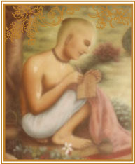
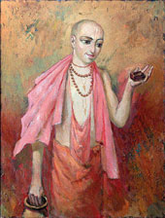
Srila Raghunatha Bhatta Goswami
3. Srila Raghunatha Bhatta Goswami
Sri Raghunatha Bhatta Goswami was born in 1505 in Eastern Bengal . His father, Sri Tapan Mishra, was a great devotee of Sri Chaitanya Mahaprabhu. Sri Tapan Mishra met Sri Chaitanya Mahaprabhu, first in Eastern Bengal, and then again in Varanasi. While in Varanasi , Sri Chaitanya Mahaprabhu used to dine at Sri Tapan Mishra's home and Raghunatha would often massage the Lord's feet. He became very attached to the Lord.
As a boy Raghunatha was adept in Sanskrit grammar and rhetoric. He became well versed in the scriptures. Upon coming of age his father sent him to Puri, where he met Sri Chaitanya Mahaprabhu. He spent eight months in the service of the Lord. He would cook for him on a regular basis. Sri Chaitanya Mahaprabhu instructed Raghunatha never to marry and to study the scriptures. He ordered him to return to Varanasi and to care for his ageing parents. He further told him that he would see Him again in Jagannatha Puri. Sri Chaitanya Mahaprabhu gave Raghunatha a tulasi garland from his neck.
When Raghunatha's parents passed away, he returned to Jagannatha Puri where he spent a further eight months in the service of the Lord. Sri Chaitanya Mahaprabhu then sent Raghunatha to Vrindavana, to study the Srimad-Bhagavatam and other revealed scriptures under the guidance of Sri Sanatana and Sri Rupa Goswami. After some time Raghunatha's disciples built a temple for Sri Gaura Govinda in Vrindavana.
Raghunatha was full of humility and meekness. He was permanently engaged in remembrance of the Lord. He passed away in 1579.
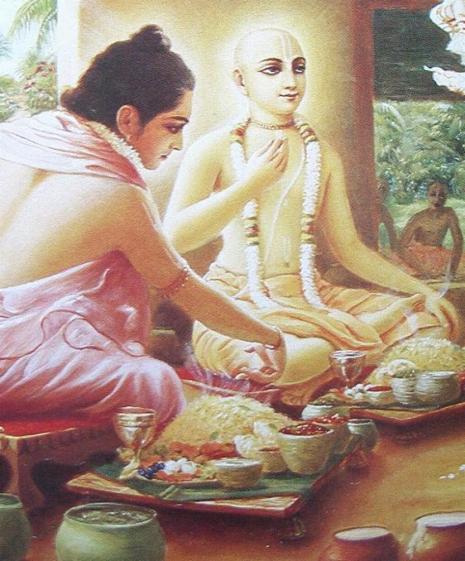
Srila Raghunatha Bhatta Goswami serving Lord Chaitanya Mahaprabhu
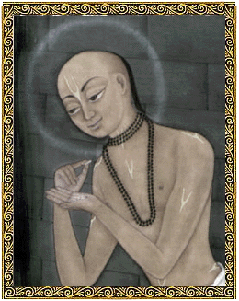

Srila Raghunatha Dasa Goswami
4. Srila Raghunatha Dasa Goswami
Srila Raghunatha Dasa Goswami is an eternally liberated associate of Lord Krishna who appeared to join the Lord when He appeared five hundred years ago as Sri Chaitanya Mahaprabhu.
Although the son of a very rich landlord, Raghunatha Dasa had no interest in the things of this world. His sole desire was to gain the association of Lord Chaitanya and dedicate himself to the Lord's service. Seeing Raghunatha's spirit of renunciation even as a young man, his family tried to keep him at home by all means, including guards. Somehow Raghunatha was able to escape their vigilance, and he made his way to Jagannatha Puri to serve Lord Chaitanya.
Raghunatha's life in Puri showed him to be absorbed in transcendental consciousness. In the Chaitanya Charitamrita, Krishnadasa Kaviraja Goswami writes: 'Who could list the unlimited transcendental attributes of Raghunatha Dasa? His strict regulative principles were exactly like the lines on a stone. Raghunatha Dasa spent more than twenty-two hours out of every twenty-four chanting the Hare Krishna maha-mantra and remembering the lotus feet of the Lord. He ate and slept for less than an hour and a half, and on some days that also was impossible.’
Topics concerning his renunciation are wonderful. Throughout his life he never allowed his tongue sense gratification. He never touched anything to wear except a small torn cloth and a patchwork wrapper. Whatever he ate was only to keep his body and soul together, and when he ate he would reproach himself thus:
"If one's heart has been cleansed by perfect knowledge and one has understood Krishna , the Supreme Brahman, he then gains everything. Why should such a person act like a debauchee by trying very carefully to maintain his material body?"'
Raghunatha Dasa Goswami served Lord Chaitanya for sixteen years at Jagannatha Puri. After the Lord departed this world, Raghunatha went to Vrindavana, where he lived for many years at the sacred lake Radha Kunda. His bhajana kutir, or place of worship, still exists there.

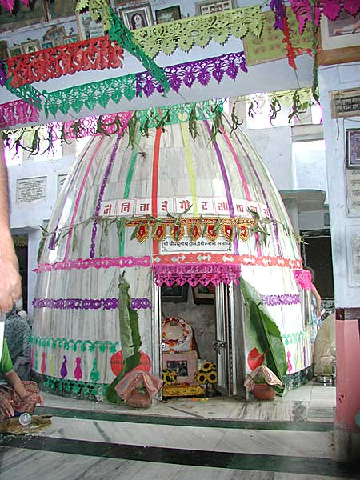
Srila Raghunatha Dasa Goswami’s Bhajan Kutir in Vrindavan, India.

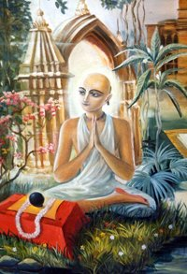
Srila Gopal Bhatta Goswami

5. Srila Gopal Bhatta Goswami
In the year 1510, while Sri Chaitanya Mahaprabhu was on tour of South India, the family of Venkata Bhatta had the great fortune of hosting the Lord during the four months of the rainy season. Gopala, Venkata Bhatta's seven-year-old son, served Lord Chaitanya continuously and developed an intense love for Him. When Lord Chaitanya was about to leave, Venkata Bhatta fainted and Gopala Bhatta's eyes filled with tears of love. For Gopala Bhatta's sake, Lord Chaitanya agreed to stay for a few more days.
During this time, Srila Gopala Bhatta Goswami had a spiritual vision in which Sri Chaitanya Mahaprabhu revealed Himself as Lord Krishna, the Supreme Personality of Godhead, and said that Gopala would someday meet in Vrindavana two jewel-like devotees — Rupa Goswami and Sanatana Goswami, leaders in Lord Chaitanya's movement. When Srila Gopala Bhatta Goswami woke from this trance, he wanted to leave for Vrindavana at once. Lord Chaitanya told him to stay back and serve his parents.
Srila Gopala Bhatta Goswami went on to study rhetoric, poetry, Vedanta, and Sanskrit grammar from his uncle Prabodhananda Sarasvati, a great devotee of Lord Chaitanya. After the passing away of his parents, Srila Gopala Bhatta Goswami travelled to Vrindavana, where he was lovingly met by Rupa Goswami and Sanatana Goswami.
When Lord Chaitanya heard that Srila Gopala Bhatta Goswami was in Vrindavana, He was extremely pleased. The Lord sent some of His personal belongings to Gopala Bhatta, who worshiped them. The Lord also sent a letter instructing Srila Gopala Bhatta Goswami to help Rupa and Sanatana compile transcendental literatures. Srila Gopala Bhatta Goswami accepted this instruction from the Lord as his life and soul, and he later engaged his disciple Srinivasa Acharya in carrying the writings to Bengal.
Once, on a trip to the Gandaki River, in Nepal, Srila Gopala Bhatta Goswami obtained twelve salagrama-silas. (A sila is a special Deity of the Lord in the form of a stone.) The silas entered his water pot as he filled it with water from the river. When he tried to return them to the river and refill his pot, they again entered the pot. Accepting this as the Lord's mercy, Srila Gopala Bhatta Goswami decided to bring the silas back to Vrindavana.
One day, Srila Gopala Bhatta Goswami felt the need to worship a Deity of Krishna. The next morning he saw that his silas had transformed into a beautiful Deity of Lord Krishna. Srila Gopala Bhatta Goswami named the Deity Radha-Ramana, ‘Krishna, who brings pleasure to Radharani.’ He established the worship of Radha-Ramana, and the Radha-Ramana temple is still one of the main places of pilgrimage in Vrindavana.

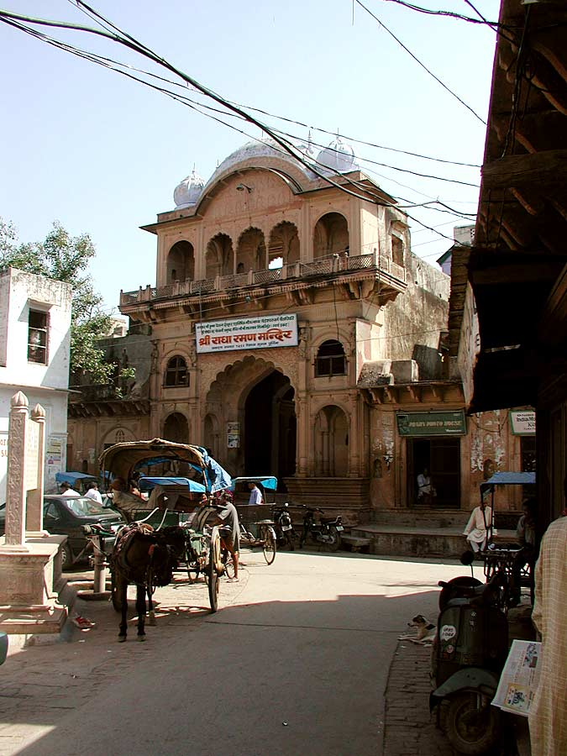
Sri Sri Radha-Ramana Mandir in Vrindavan, India.

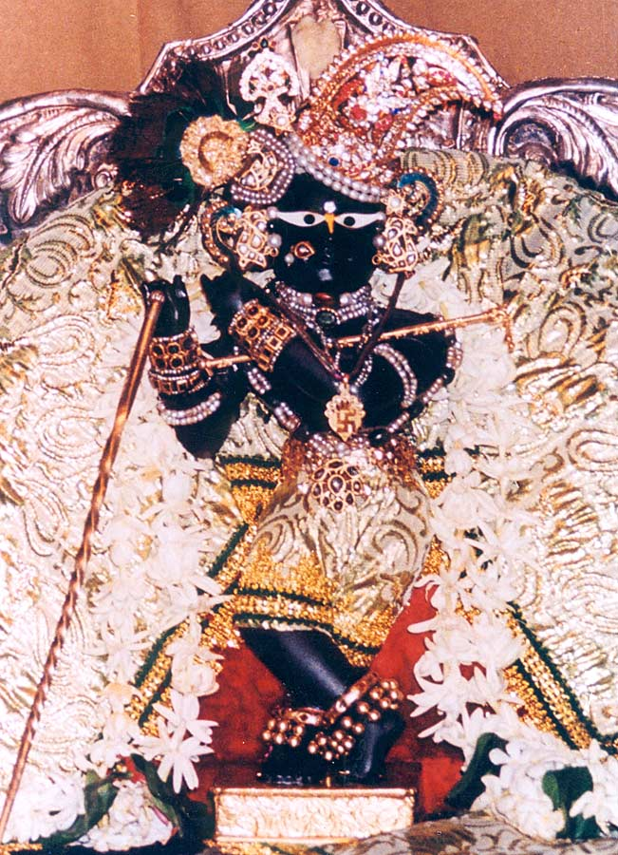
Deity of Lord Radha-Ramana at the Sri Sri Radha-Ramana Mandir in Vrindavan, India.
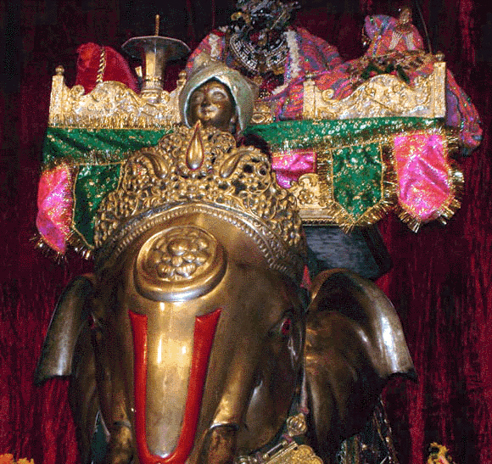
Srimati Radharani on a golden elephant at Sri Sri Radha-Ramana Mandir in Vrindavan, India.
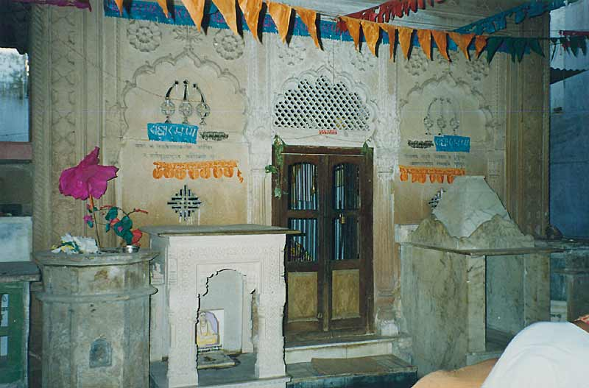
Srila Gopal Bhatta Goswami’s Samadhi in Sri Sri Radha-Ramana Mandir, in Vrindavan, India.

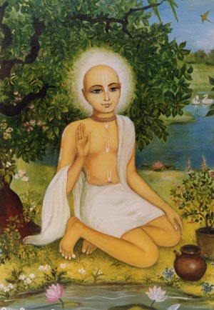
Srila Jiva Goswami

6.Srila Jiva Goswami
Srila Jiva Goswami was the son of Sri Vallabha and nephew of Sri Sanatana, Sri Rupa, all of whom were employed in the service of the Badsha Hussein Shah. Having been rewarded richly by the Badsha for their services, their household life was very opulent.
When Sri Chaitanya Mahaprabhu came to Ramakeli, Sri Jiva was blessed by having darshana of his worshipable Lord, though he was just a baby at that time. Mahaprabhu indicated him to be a great future scholar in the Gaudiya sampradaya. Though he was only a child, Sri Jiva would meditate on Sri Chaitanya constantly.
Later on, when his father and uncles renounced their family life in order to be with Mahaprabhu, the only child, Sri Jiva, was left with his mother in the family palace at Fateyabad. Jiva missed them greatly and whenever he would remember his father and uncles, or Sri Chaitanya he would lose consciousness.
As he grew up, Sri Jiva took up the worship of the Deities of Sri-Sri Rama-Krishna. He would carefully decorate them and offer Bhoga and Arati, serving them with his full attention. Even in his play, whatever games he played were connected with Sri Krishna's pastimes.
While studying under the local pandits he became proficient in grammar, poetry and rhetoric. His teachers noted his great intellect. When Sri Jiva learned that his father had passed away on the banks of the Ganga, he was completely unsettled. Family members and friends tried to console him but to little avail. Family life had become the source of his utter sadness. Someone suggested that he go to Navadvipa and see Lord Nityananda, so he set out for Navadvipa with a group of pilgrims. Everyone at Navadvipa was very happy to meet the nephew of Sri Rupa and Sanatana.
Sri Jiva spent some days with Nityananda Prabhu, touring the nine islands of Navadvipa, in order to visit the holy places of the Lord's pastimes there. Then, as ordered by Nityananda Prabhu, he set out for Kashi (Varanasi). At Kashi he studied Vedanta under Sri Madhusudana Vachaspati, a disciple of Sarvabhauma Bhattacharya. The conclusions of Vedanta contained in Srimad-Bhagavatam that were expounded by Sri Chaitanya Mahaprabhu to Sarvabhauma Bhattacharya in Puri had been in turn taught by the Bhattacharya to Madhusudana Vachaspati, who established a school at Kashi. From here Sri Jiva set out for Vrindavana where he received shelter at the lotus feet of his two uncles, Sri Rupa and Sanatana. Jiva stayed with Sri Rupa, who began to teach him Srimad-Bhagavatam. After initiating him with the divine mantra, Rupa engaged him in the service of Sri Sri Radha-Damodara. Seeing that Jiva had quickly become conversant with the conclusion of Srimad-Bhagavatam, Sri Rupa engaged him in proof-reading his Bhakti-rasamrita-sindhu. At this time Sri Jiva compiled a commentary on Bhakti-rasamrita-sindhu called Durgama-sangamani. Sri Sanatana Goswami compiled Sri Vaishnava-tosani, a commentary on the tenth canto of Srimad-Bhagavatam, which he gave to Sri Jiva for proof-reading. Under the order of Sri Sanatana, Sri Jiva compiled a commentary on that named Laghu Vaishnava-tosani. His writings, along with those of Sri Rupa and Sri Sanatana, Sri Gopala Bhatta, Sri Raghunatha Bhatta, Sri Raghunatha Dasa, Sri Krishna Dasa, Sri Kashishvar Pandita, and Sri Madhu Pandita, completely captivated the learned men of that time.
It was the beginning of a golden age at Vrindavana. Sri Jiva regularly brought water for Sri Rupa and Sanatana's bath. He massaged their heads with oil, cleaned their ashrama, worshiped the Deity, cooked and corrected manuscripts.
After the passing away of Sri Rupa and Sanatana, Sri Jiva continued the tradition that they had inaugurated. Once Sri Jiva travelled to Agra to debate with the Rajputs concerning the glories of Yamuna and Ganga rivers. He established that the Yamuna is more glorious than the Ganga as the Ganga emanates from Krishna's lotus feet whereas the Yamuna is His own consort. At this the Mogul emperor was very much satisfied and wanted to present him something. Sri Jiva replied that he would accept some blank papers. So the emperor presented Jiva some stained paper. (At that time paper was very rare and most manuscripts were usually composed on leaves.) There is also a legend that once, when a Mogul emperor (possibly Akbar) wanted to confer something on the Goswamis of Vrindavana, they requested a farman (emperor's order) that no living beings would be killed within Vraja. As a result of this no king would come to hunt there anymore.
The disciple of Lokanatha Goswami, Narottama Dasa Thakura Mahashaya, Sri Gopala Bhatta Goswami's disciple Srinivasa Acharya Prabhu, and the disciple of Chaitanya Prabhu, Sri Shyamananda Prabhu, were greatly favoured by Srila Jiva Goswami. Under his tutelage they studied all the literatures of the Goswamis. Later he sent them to preach this knowledge in Bengal. Srila Jiva Goswami composed many literatures. He passed away in 1618 in Vrindavana.

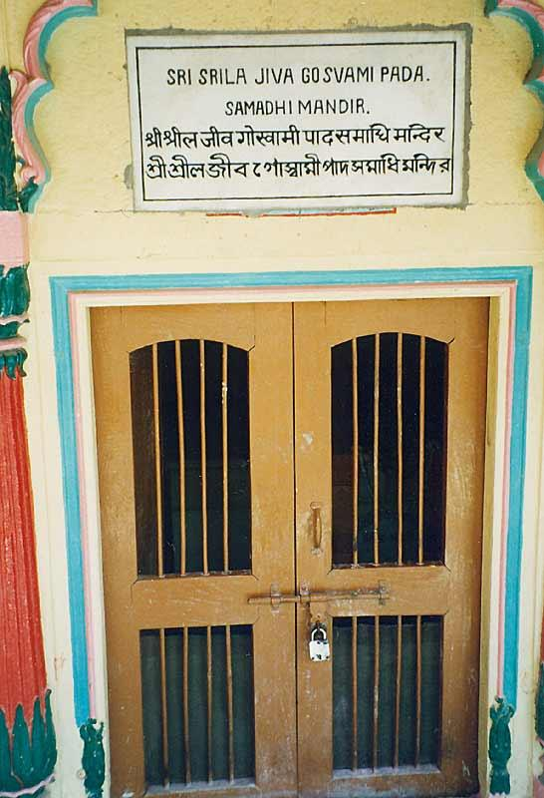
Srila Jiva Goswami’s Samadhi Mandir.

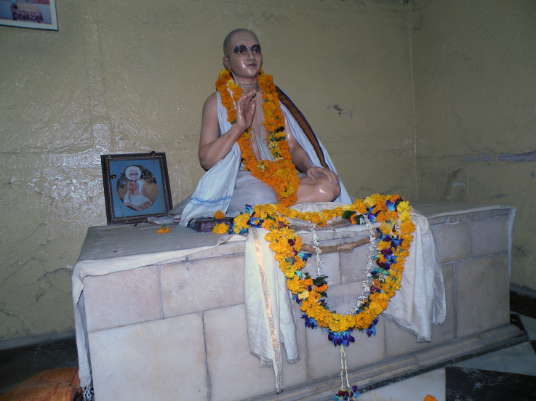
Srila Jiva Goswami’s Samadhi

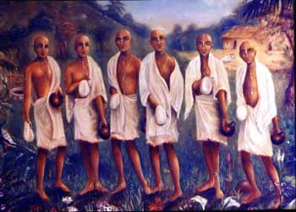
The Six Goswamis of Vrindavan

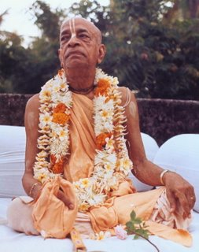
Dedicated to His Divine Grace A.C. Bhaktivedanta Swami Prabhupada, Founder Acharya of the International Society for Krishna Consciousness.
Dedicated in the loving devotional service of Lord Sri Krishna and His Divine Grace A.C. Bhaktivedanta Swami Prabhupada, Founder Acharya of the International Society for Krishna Consciousness, ISKCON.

Written, Edited, Published and Distributed by,
Rasabihari Dasa (Vinay. D. Chakraborty)

Do send us your views, comments, suggestions or queries if any to vinay.chakraborty@yahoo.com or visit www.soldiersofgodhead.yolasite.com for more information.
You can also send us articles you wish to include in this magazine or write to us the topics on which you want articles in this magazine. You may send your articles or desired topics to the above email id.
Hare Krishna!

